

**Project Report: - CHATBOT IN PYTHON**

Submitted by: Pratham Goel

Univ. Roll. No: 2014434

Section: G

UNDER THE GUIDANCE OF

Dr. Guru Prasad M S

**DEPARTMENT OF COMPUTER SCIENCE AND INFORMATION TECHNOLOGY**

**GRAPHIC ERA DEEMED TO BE UNVERSITY DEHRADUN**

**CERTIFICATE**

Certified that Mr. PRATHAM GOEL (Roll No.- 2014434) has developed mini project on “Chatbot in Python” for the CS III Semester Mini Project Lab (PCS-333) in Graphic Era Deemed to be University, Dehradun. The project carried out by Students is their own work as best of my knowledge.

Date:

Dr. Guru Prasad M S

Resource Person

(CSE Department)

**ACKNOWLEDGMENT**

I would like to express our gratitude to The Almighty God, the most Beneficent and the most Merciful, for completion of project.

I wish to thank our parents for their continuing support and encouragement. We also wish to thank them for providing us with the opportunity to reach this far in our studies. I would like to thank particularly our project Resource Person Dr. Guru Prasad M S for his patience, support and encouragement throughout the completion of this project and having faith in us.

I also acknowledge to teachers like Mr Akshay Rajput who help us in developing the project.

At last but not the least I greatly indebted to all other persons who directly or indirectly helped us during this work.

**Mr. PRATAHAM GOEL**

**Roll No.- 2014434**

**CSE-G-III-Sem**

**Session: 2020-2021**

**GEU, Dehradun**

# Abstract

* A Chatbot is a computer program that simulates and processes human conversation (either written or spoken), allowing humans to interact with digital devices as if they were communicating with a real person
* Conventionally web-bots exist; web-bots were created as text based web-friends, an entertainer for a user
* It is designed in a way keeping in mind the human response as a conversational partner.
* The chatbot I present generates a dynamic reply for the user either by using a pre-defined dataset or by combining information from the respected useful websites and answer the query of the user.

# Project Introduction

* Chatbot experiences can happen through text or voice interactions and can be valuable depending on the context.
* Sometimes it is powered by machine learning (the chatbot gets smarter the more you interact with it).
* Or it is driven using intelligent rules (i.e., if the person says this, respond with that).
* The Chatbot I created follows a set of rules, flows, and triggers to respond to very specific commands.
* I Have combined the chatbot with a virtual assistant which can talk and do some simple but unique tasks.

# Project Motivation

* In today’s era, having someone that can do task just by a command is the necessity.
* Keeping this in mind, I created a chatbot which not only answers your query but also can help you do some of you daily tasks just by writing a simple command.

# Methodology Followed

1. **Libraries Imported**
   1. Selenium

* Selenium Python bindings provide a convenient API to access Selenium Web Drivers like Firefox, I.e., Chrome, Remote etc.
* Selenium is a powerful tool for controlling web browsers through programs and performing browser automation.
  1. Datetime
* The datetime module supplies classes for manipulating dates and times.
* The focus of the implementation is on efficient attribute extraction for output formatting and manipulation.
  1. Wikipediaapi
* It supports extracting texts, sections, links, categories, translations, etc from Wikipedia.

1. **Functions Created**
   1. Start ()

* This function is acting like the core of my chatbot.
* Every other function is directly or indirectly linked with this function.
* This function takes the input string and checks which function is to be called next based on this string.
  1. You_Tube(video)
* This function opens chrome browser and plays the Video in youtube.
* Automatically skips the Ad presented by youtube.
* Plays the video in full screen mode.
* And then the chatbot goes to sleep waiting for another command.
  1. Waitbrowser(browser)
* This is the waiting function which loops till the name of the chatbot is called.
* The video still runs in the background.
  1. Wait ()
* Wait function will put the chatbot to sleep and wake it only when its name is called.
  1. Wikipedia(line)
* It will search for the requested information and returns summary of 1500 words.

# Result

Chatbot named Zarvis is working very well using the functions which are there to be defined.

**CODE SCREENSHOTS**

**Importing libraries:-**

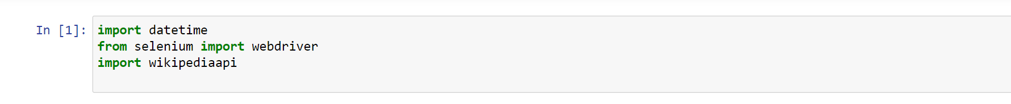

**Definiing Functions:-**

You_Tube(video)

Wikipedia(line)

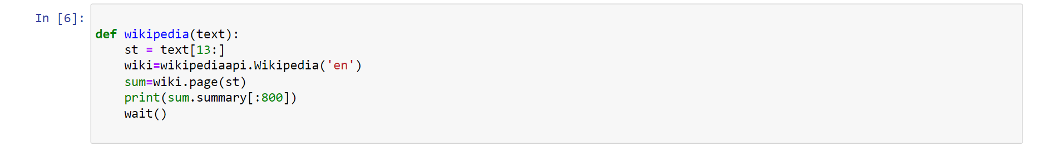

Datetime

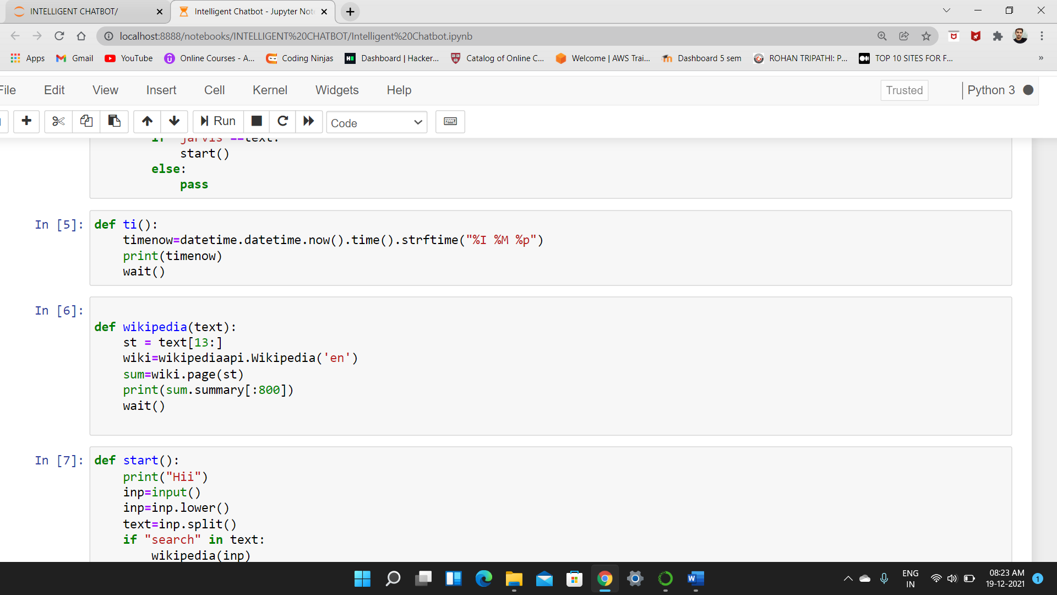

Start ()

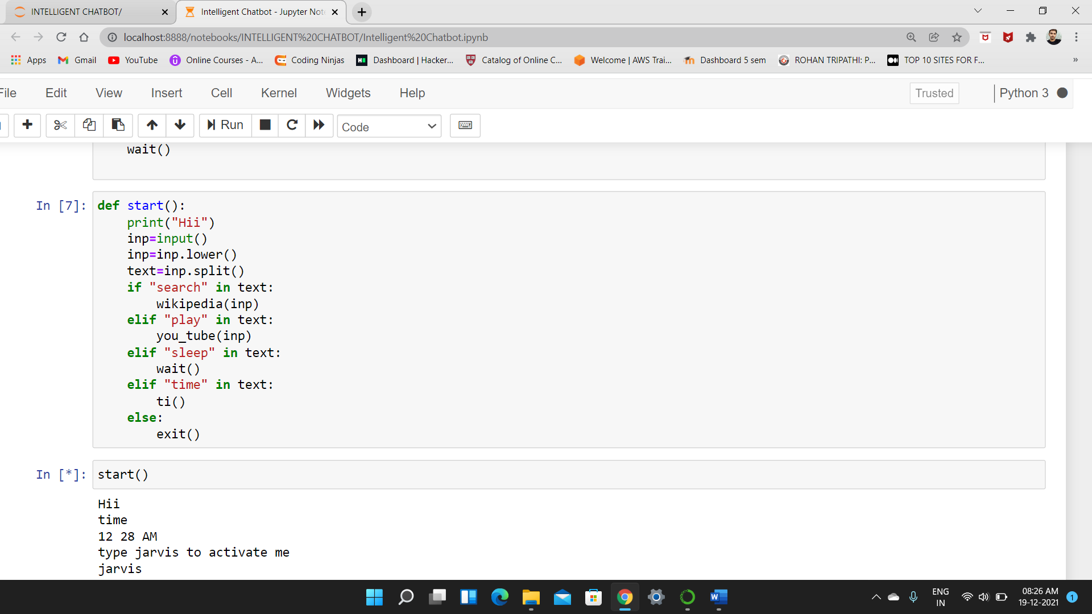

**REFERENCES:**

1. Workshop in GEU BY Mr.ASHISH GARG on Intelligent Chatbot
2. <https://towardsdatascience.com/> (Site related to knowledge about AI & ML)
3. [www.google.com](http://www.google.com)